Pedestrian Safety Month Kit

October is Pedestrian Safety Month and International Walk to School Month!

Kit for Schools
What’s included in the kit:
- Why Walk, roll, cycle to school? – Benefits of active transportation
- Pedestrian Safety Month Checklist
- Sample Announcements – to promote Pedestrian Safety Month in school.
- Sample E-mail (or Newsletter) – to promote Pedestrian Safety Month to families/staff.
- Sample Tweets – to promote Pedestrian Safety Month with the school community.
- Pedestrian Safety Messaging – tips to make sure students and families stay safe.
- Activities – take-home and in-school activities to promote walking and rolling.
  - Pedestrian Safety Month Bingo
  - Pedestrian Safety Month Scavenger Hunt
  - Pedestrian Safety Month Wordsearch

Why Walk, Roll, Cycle to School?

- Walking, rolling, and cycling to school helps students arrive more alert and ready to learn.
- Physical activity improves student’s attention in the classroom.
- Walking, rolling, and cycling to school reduces stress, depression anxiety, and improves mood.
- Students can become familiar with and interact with their peers and the environment.
- Decreases congestions from traffic and students being dropped off by vehicles, reducing greenhouse gas emissions while saving time and money.
- Creates safer school zones with fewer cars. Students also learn important safety skills by walking.

Pedestrian Safety Month Checklist
Pedestrian Safety Month takes place in October, as well as International Walk to School Month. Schools should plan and promote events for and make announcements during this time. This kit will guide you through planning and executing fun walking, rolling, and cycling events for your school community, as well as providing safety tips for students.
- Plan your events: Promote your events using our sample announcements, tweets, and newsletters to get the word out in the school community. Promote Pedestrian Safety Month and International Walk to School Month by holding a kick-off assembly to promote Pedestrian Safety Month, have contests, activities, art projects, group walks, an information table at your school and more.
- Invite the school community: Invite parents and guardians, school board trustees, local transportation groups, secondary school students, and others as desired to support your Pedestrian Safety Month activities.
- Highlight your events: Use #PedestrianSafetyPeel and #VisionZeroPeel and tag @RegionOfPeel to share your adventures during October.

Resources
Please share these resource links with your class and the school community before and during Pedestrian Safety Month.
- City of Mississauga – Walk to School Month
  - Walk to school – City of Mississauga

- Green Communities Canada – Hands-Up for Better Data!
  - Celebrate Bike, Walk, Roll Week with thousands of schools across Canada!
  - Bike Walk Roll Week - SchoolTravel.ca
- Walk and Roll to School guide for parents and guardians
  - Helps parents/guardians feel secure and confident in encouraging students to use active transportation during their commute to school.

- Peel Region Cyclist Handbook
  - Will teach you about your bicycle, traffic laws, and safe cycling habits.

Videos
Please share these videos with your class and the school community.
Peel Region
- Vision Zero: Safer roads in Peel
Peel District School Board
- Safety is Everyone’s Responsibility
- Get Fit!
- Academic Benefits

Sample Announcements

School announcements are an effective way to promote Pedestrian Safety Month and keep your school community engaged. Please modify the specified content to adapt the announcements for your school. We also encourage students and staff to create their own announcements to promote Pedestrian Safety Month events.
Before Pedestrian Safety Month:
Good morning staff and students. This October, <School Name> is participating in Pedestrian Safety Month! For the whole month, we are encouraging students and families to walk, roll, or cycle to school as much as possible. Dust off those walking shoes and meet up with some friends to walk to school this month!
Walking improves your mental health, helps you learn about your community, and makes a safer area by reducing traffic and pollution. We all play a role in making our roads safe for everyone. This Pedestrian Safety Month, follow some safety tips when travelling to school:
- Stop, look, and listen before crossing when it’s your turn to cross.
- Always cross at pedestrian crosswalks, or crossovers. Avoid crossing anywhere else.
So, who’s ready to get walking this month? <School Name> is excited to participate and we can’t wait to see you all walking and rolling to school, and being safe!
First day of Pedestrian Safety Month:
Good morning staff and students. October is Pedestrian Safety Month at <School Name> and today marks the first day! It was great to see so many of you walking and rolling to school this morning. Walking improves your mental health and makes your community safer and cleaner. Don’t forget to get walking for the rest of the month, and let’s see what our school community can do!
Don’t forget <School Mascot> to always be safe when walking, rolling, and cycling to school. Here’s some more safety tip that everyone can follow:
- Make eye contact with drivers to ensure they see you before you cross.
- If cycling to school, make sure that all of your bicycle and reflectors are working properly, and don’t forget your bicycle helmet.
Optional Announcement if school is participating in ‘Hands -Up for Better Data:
Good morning staff and students. Green Communities Canada is celebrating Bike Walk Roll Week with thousands of schools across Canada! This nation-wide initiative is to collect data about how we all travel to school. <School Name> is going to participate, so during the week of October 16th to 20th, every class will be recording how they travel to school. So <School Mascot> let us get active and walk, roll, cycle to school during this week. Please reach out to your teacher for more details on Bike Walk Roll Week!
Halloween Pedestrian Safety Month:
Good morning staff and students. Happy Halloween! A friendly reminder if you plan on trick-or-treating tonight to be extra careful and safe. Here are some safety tips for tonight:
- Stop, look, and listen before crossing, even when it is your turn to cross.
- May eye contact with drivers to ensure they see you before you proceed.
- It’s harder to be seen when it’s dark out, be extra safe, wear reflective materials, or bring a flashlight so others can see you.
Enjoy all the tricks and treats!
During Pedestrian Safety Month:
Good morning staff and students. We love seeing all <School Mascots> walking, rolling and cycling to school these past few weeks. What a great way to start your day! Let’s keep the momentum going for the rest of the month! Let’s challenge ourselves to walk, roll and cycle to school during October!
After Pedestrian Safety Month:
Good morning staff and students. Now that Pedestrian Safety Month is over, we would like to congratulate you all on a great month full of walking, rolling, and cycling! Although Pedestrian Safety Month has ended, you can still walk and roll to school whenever you can. Thank you <School Mascot Name> everyone!

Sample E-mail (or Newsletter)

Find below an e-mail or newsletter template that you can use to update your school community on Pedestrian Safety Month. It may also be posted as a website announcement or another format as desired. Please modify the specified content.
Hello <Staff/Parents>
This October is Pedestrian Safety Month (Pedestrian Safety Month) and International Walk to School Month! <School Name> will be taking part this month by encouraging students and families to walk, roll or cycle to school as much as possible.
Pedestrian Safety Month is a celebration and promotion of active transportation, with a focus on walking and safety. Schools across Ontario are coordinating activities focused on walking and rolling to school to promote active transportation to improve the health of both students and the environment. By choosing to actively travel to school, students and families help to reduce traffic, improve air quality, and promote physical and mental health. Students who walk or roll to school arrive more alert, focused, and ready to learn.
Families can prepare by discussing routes with their children and providing tips to stay safe while walking and rolling. We all play a role in making our roads safe for everyone. Please share these safety tips with your family:
- Stop, look, and listen before crossing, even when it’s your turn to cross.
- Always cross at pedestrian crosswalks, or crossovers. Avoid crossing anywhere else.
- Always press the pedestrian pushbutton. Pressing the button will activate the ‘Walk’ signal and give you more time to cross.
- Once ‘Don’t Walk’ hand signal starts flashing, you can finish crossing, but don’t begin to cross. Wait for the next ‘Walk’ signal.
- Avoid distractions like texting, cellphones, and headphones when crossing the street.
If students live too far away to walk their entire route, consider walking to a bus stop or parking further from the school. We encourage students and families to participate wherever possible, and we look forward to seeing students walking and rolling to school this October!
Peel Region is making infrastructure changes to improve pedestrian safety as part of the Vision Zero Road Safety Strategic Plan.
Regards,
<School Information>

Sample Tweets

Use #PedestrianSafetyPeel and #VisionZeroPeel to share your school community’s progress and events during Pedestrian Safety Month. Find some sample tweets below to promote Pedestrian Safety Month. Please modify the specified content.
Pedestrian Safety Month is this October! <School Name> students and families, dust off your walking shoes this month and get active on your way to school! #PedestrianSafetyPeel #VisionZeroPeel
<School Name> let’s all work together to stay safe while walking, rolling, and cycling to school. Remember, to stop, look, and listen before crossing, even when it’s your turn to cross. #PedestrianSafetyPeel #VisionZeroPeel
Happy Pedestrian Safety Month! Get walking to school this October and help reduce traffic and pollution while improving your mental and physical health. Have fun! #PedestrianSafetyPeel #VisionZeroPeel
<School Name> students have been walking and rolling to school this month! Walking or cycling to school is a great way to learn more about your community, spend some extra time with family or friends, and improve your mood. Keep it up <School Mascots>! #PedestrianSafetyPeel #VisionZeroPeel

Pedestrian Safety Messaging to Promote

Pedestrian Safety Month is an effective way to promote safety tips for students to use while walking to school or elsewhere in their community. As part of the Peel Region’s Vision Zero plan, the Region is working with municipal partners and you to reduce injury and deaths caused by collisions in Peel. This section contains safety tips for pedestrians that schools should promote during Pedestrian Safety Month.
Did you know that more than half of collisions between pedestrians and cars happen when drivers make a turn while pedestrians are crossing with right-of-way.
Let’s work together to stay safe while sharing the road.
- Stop, look, and listen before crossing, even when it is your turn.
- Follow pedestrian safety signals and always pay attention.
- When possible, make eye contact with drivers to ensure they can see you before you cross.
- Always cross at a pedestrian crossing, crosswalk, or intersection.
- Avoid distractions while crossing, such as texting or wearing headphones.
- Wear bright clothing or reflective materials to increase your visibility to cars in the dark.
- If you are in an area with no sidewalk, walk along the left side of the road, facing oncoming traffic.
Three steps to keeping safe when crossing the road:
- Press the pushbutton and wait for the walk signal.
- When you see the walk signal, look all ways, and make eye contact with drivers to ensure that they see you before you start to cross. Be seen and be aware.
- Finish crossing before the hand signal stops flashing. Do not start crossing when the hand signal is flashing.

Pedestrian Safety Month – Bingo
- Print and share the Pedestrian Safety Month Bingo card for students to explore being outside.
- Refer to Appendix A for an example of the Pedestrian Safety Month Bingo card. This card will be provided as an attachment for you to print for your students.

Pedestrian Safety Month – Scavenger Hunt
- Print and share the Pedestrian Safety Month Scavenger Hunt for students to explore during their journey to school.
- Refer to Appendix B for an example of the Pedestrian Safety Month Scavenger Hunt activity. This activity will be provided as an attachment for you to print for your students.

Pedestrian Safety Month – Word Search
- Print and share the Pedestrian Safety Month Word Search for students to learn about key safety words.
- Refer to Appendix C for an example of the Pedestrian Safety Month Word Search activity. This activity will be provided as an attachment for you to print for your students.

References
Appendix A: Pedestrian Safety Month BINGO
Appendix B: Pedestrian Safety Month SCVANGER HUNT
Appendix C: Pedestrian Safety Month WORD SEARCH

For more information, please visit: peelregion.ca/environmental-education/transportation/pedestrian-safety-month.asp

Appendix A: Pedestrian Safety Month BINGO

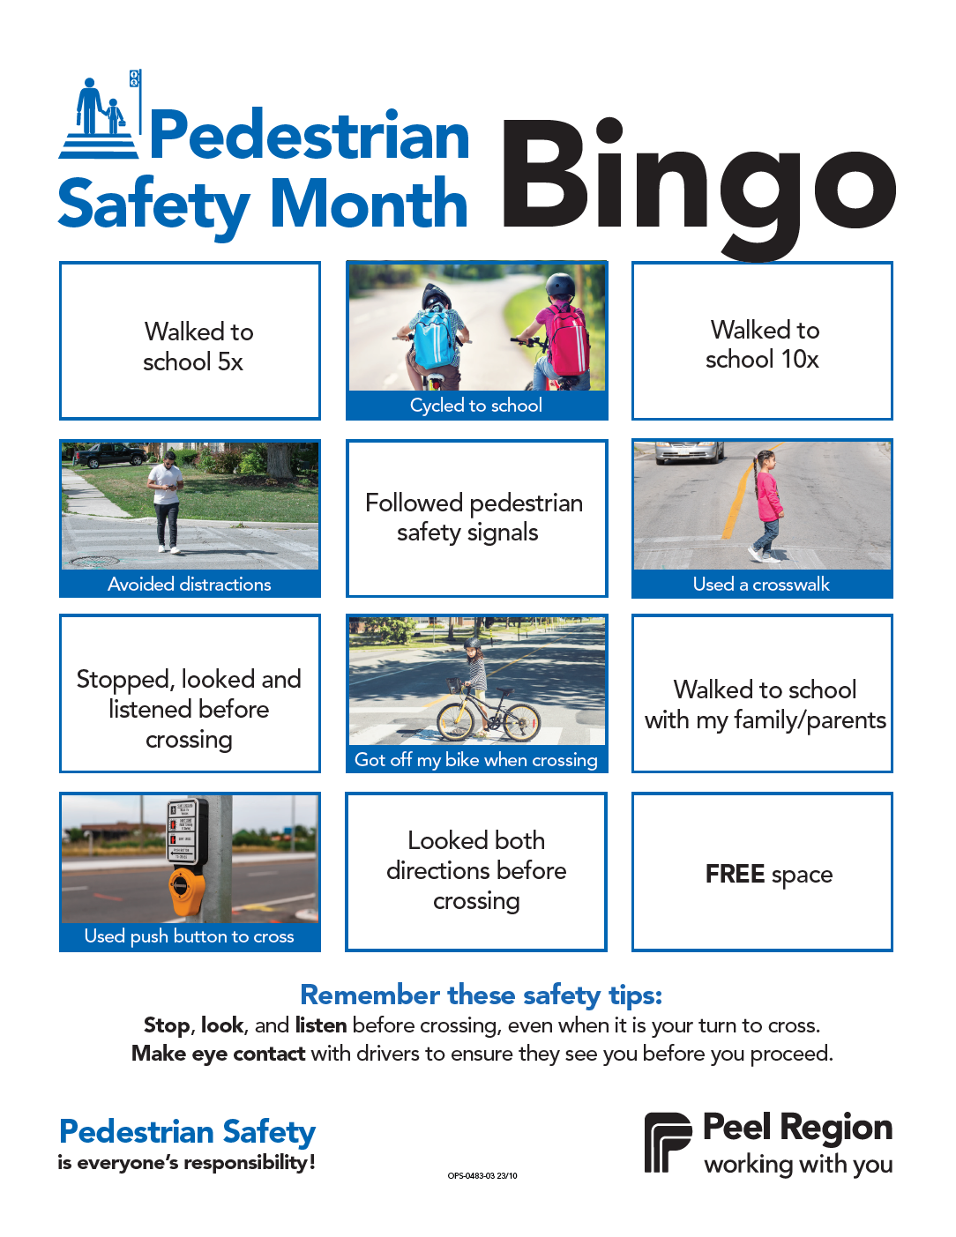
Appendix B: Pedestrian Safety Month SCVANGER HUNT

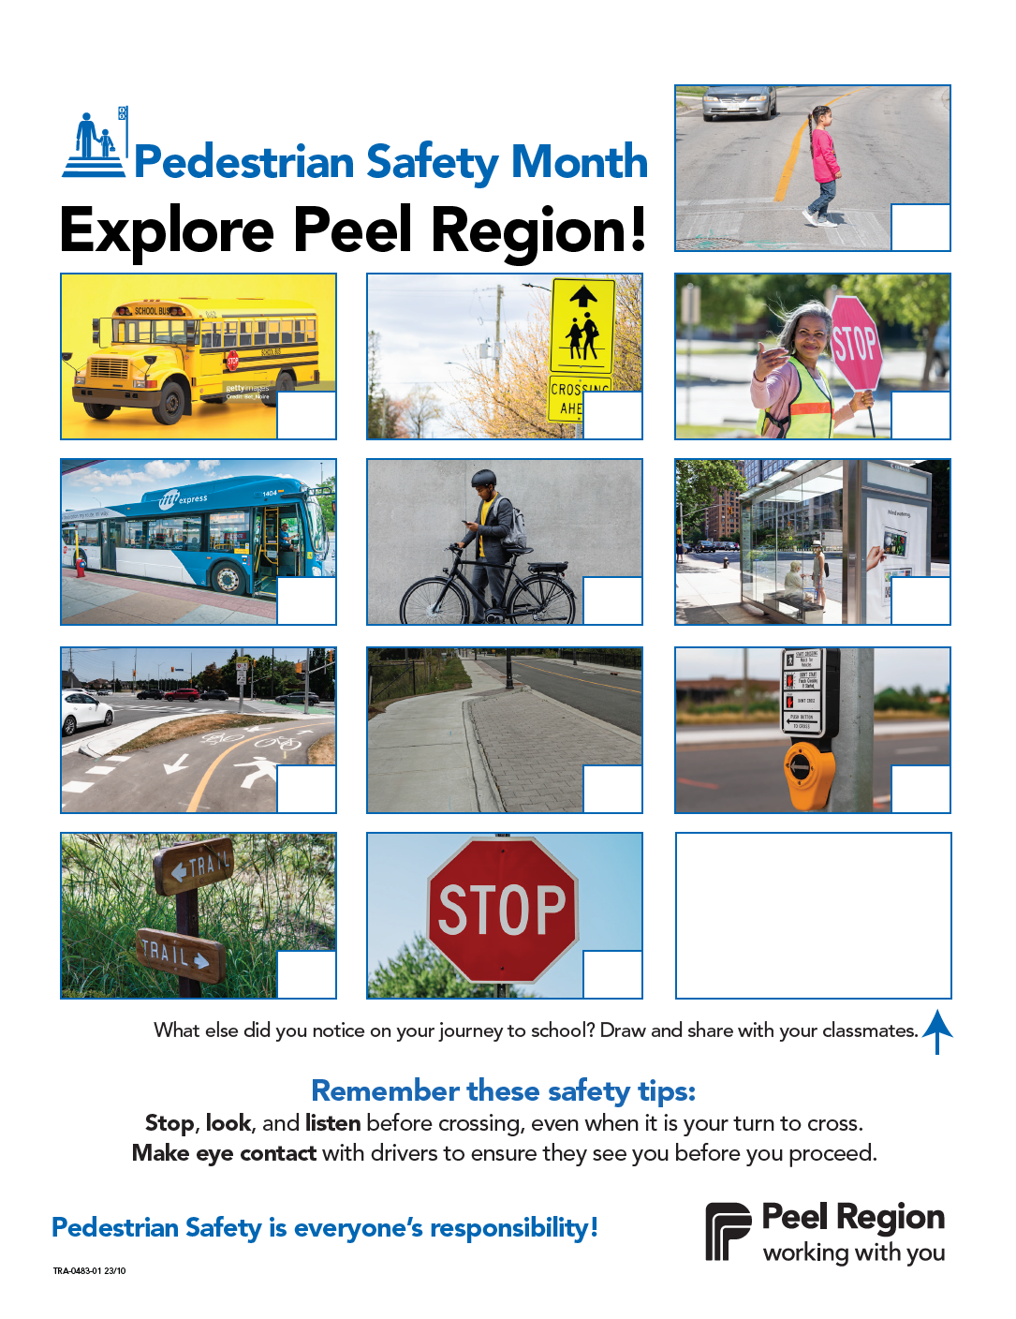
Appendix C: Pedestrian Safety Month WORD SEARCH

