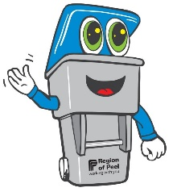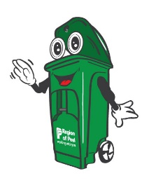

Activity Sheet - Primary

**Waste Detectives Scavenger Hunt**

Hunt around your home and neighbourhood for these items.

Check them off once you have found them!

|  |  |  |
| --- | --- | --- |
| □ A garbage bin | □ A recycling bin | □ A green bin |
| □ A garbage item | □ A recyclable item | □ A food scrap item   |
| □ A reusable item    K:\ETPS\Programs\Bus&Info\Environmental Education\Waste Education Programs\ROP Development\Photos\istock purchased\iStock_000042721694_Large.jpg | □ A recycling symbol | □ A plant growing in soil |

