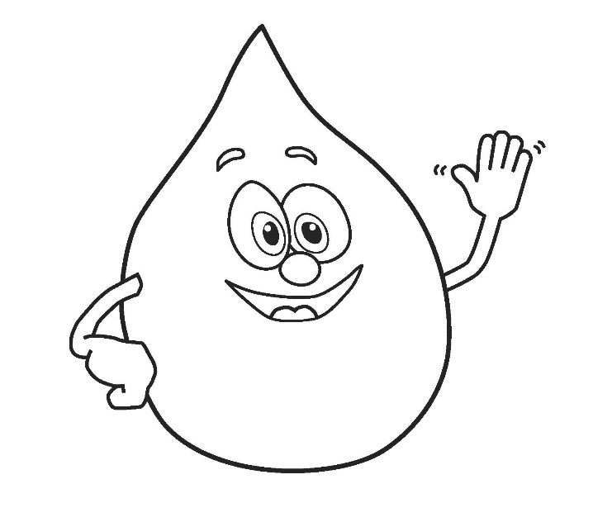
Watch the following videos to learn more about FOGS – Fats, oils and grease:
- I Don’t Flush – A Prescription for Clean Water
https://www.youtube.com/watch?v=HBQ87GzRQvc

- I Don’t Flush – Trash your bad habits, not your drain
https://www.youtube.com/watch?v=GttA69HMFcQ

- I Don’t Flush – fats, oil and grease
https://www.youtube.com/watch?v=5HMdVuxQ-KU

Work in groups to create a public service announcement about FOGS. Think of the following:

- What would your prescription for clean water be?
- What would you include in your message?
- How would you engage your audience?
- What tactics would you use to motivate behaviour change?
- Why is this message important to reach an audience?

Share your PSA with the class or the entire school community, some neat ideas you can look into doing include:

- Poster
- School Newsletter
- School Announcements
- Virtual Assembly
- Video

