School Active Transportation Handout
Name: ______________________________________________________

Planning a Community for Life
Watch the short video and answer the following questions.
- What is Peel Region’s goal as we manage growth?

- Do you have another goal that you would include to build a better community for all?

Activity 1: Road safety infrastructure and Vision Zero
For this activity, you will explore and learn about the different types of infrastructure that Peel is using to improve road safety, promote active transportation and help achieve Vision Zero.
Vision Zero means no loss of life is acceptable due to a motor vehicle collision.
Complete the table below, by filling in the definition for each type of infrastructure.
Road Infrastructure | Definition
Pedestrian push buttons
Crosswalks
Bike lanes
Crossrides
Multi-modal pathways

Activity 2: Road safety infrastructure in your neighbourhood
Familiarize yourself with the ‘Walk & Roll Peel School Walk/Bike Times’ map. Identify the various features you will use on the map, including the search bar, legend, and zoom functions.
Legend
Expand the map area

Legend

Search function
Viewing Modes:
Preview on Phone
Preview on Tablet
Preview on Desktop
Preview on Fullscreen
X Exit out of the window
Schools | 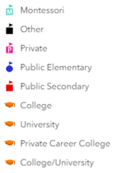
Trails | 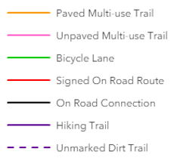
School Walk/Bike (Minutes) | 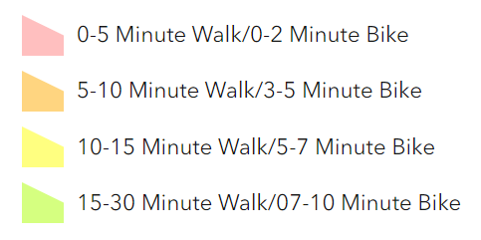

- Select the magnifying glass/search icon and enter your school name. Make sure the suggested address that appears is in the correct city and country before selecting it.
- Select the legend icon and familiarize yourself with the different features included on the map (schools, crossing guard, trails, school walking and bike times).
- Select the zoom in and zoom out icons for getting a closer look on the map and for zooming out on the map.

- What are some of the features listed on the legend?

- What are some features you notice when you look at the area around your school?

- How many multi-use trails are available around your school?

- Find your home on the map and click on the surrounding area. A walk-time box will show up. Scroll through the records using the arrows at the bottom of the box until you see the walk times for your school.

  - How long it would take you to walk/bike to school?

  - Are you surprised with the findings? Why, or why not.

Activity 3: Environmental benefits of active transportation
The 2016 Transportation Tomorrow study found in 2016, the Region of Peel had a total of 660,200 trips made by residents. Refer to the chart and answer the questions below.
 | Driver | Passenger | Transit | Go Train | Walk & Cycle | Other
Mode of Travel | 63% | 13% | 8% | 4% | 8% | 5%
Median Trip Length (km) | 8.9km | 3.4km | 10.4km | 27.7km | N/A | N/A

- What stands out to you from this study?

- This study was completed 7 years ago, do you think the values are similar today?

- Do you think residents in Peel are trying other modes of travel rather than driving?

  - What would encourage you to walk or cycle more?

- Use the table below to survey your class and ask how they get to school. Is the distribution of trips similar to the Transportation Tomorrow study?
Main mode of transportation to/from school | Tally (# students) | % Distribution by travel mode
Drive
Carpool
Public transit
Walk
Cycle/Scooter
Other
TOTAL

Making an impact
After completing the StoryMap, reflect on how active transportation is important for everyone to learn more about. Think about the health benefits of walking, cycling and being outside instead of getting a drive to school.

- How could you promote active transportation at your school?

- What does active school travel mean to you?

