Update on construction in your area

The Region of Peel is replacing aging watermain on Indian Grove as part of our maintenance program. The current watermain was installed in the 1950s and is at the end of its lifespan.
A larger watermain that provides water to the Lorne Park area will also be installed along with the smaller (local) watermain on Indian Grove. The local watermain is on one side of the street with the larger watermain to follow on the opposite side of the street.

Completed work

- The Contractor has finished installing the main pipe pieces for the new large watermain on Indian Grove from South Sheridan Way to Indian Road, including installation of a chamber to house an air valve (see the “Did you know” section below).
- Sections of temporary asphalt curb have been installed in advance of the winter. Some driveway aprons have also been temporarily restored with asphalt until final restoration is completed in spring 2022. If we damaged your driveway and cannot fully repair it before winter, we have put down a thin layer of asphalt so we don’t leave your driveway as gravel. This will be removed in the spring when the weather allows for proper restoration.
- Final curb and sidewalk restoration has been completed on South Sheridan Way and on the west side of Indian Grove near Tim Hortons.
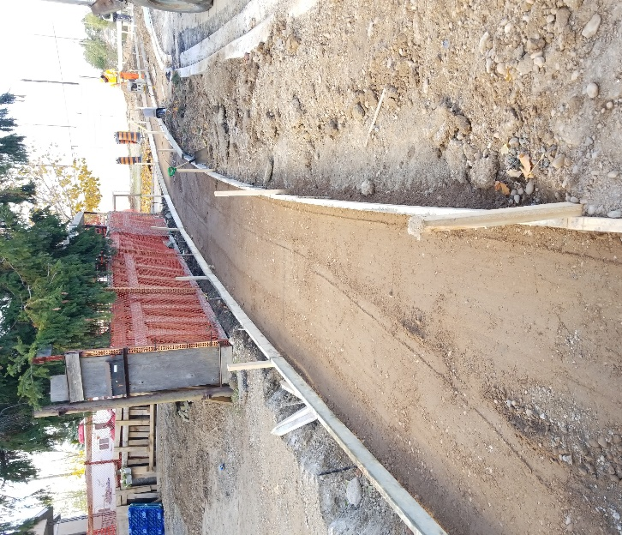
Forms for sidewalk at the north end of Indian Grove
Resident questions/concerns

- Residents have expressed concerns about the protection of trees on their front lawns. The Contractor is using smaller equipment to minimize the risk of damaging overhanging branches and is taking care to avoid hitting branches. Overhanging branches may need to be trimmed in some areas.
- Construction activities can generate a lot of dust and dirt. The Contractor has been putting down calcium chloride for dust suppression and a street sweeper comes to site twice a week to clean the road. The street sweeper may not always use water when sweeping as there is a risk of freezing in the winter.
- Residents have noted that granular material piled in the road has been encroaching on driveways. We will work with the contractor to keep driveways clear and to ensure that granular piles are maintained.
- A generator was running for approximately a week to keep the excavation around a chamber dry, creating a lot of noise. This chamber has been backfilled and a generator is no longer required.
- Old watermain pipes are sometimes piled on the road for a while. It is most cost effective for the Contractor to remove all old pipes and material once they have a full load. Until that time, they are expected to clearly mark piles of debris (e.g. with barrels) and to keep the piles tidy and contained to ensure that they are not a hazard to motorists.
- Leaves have been piled on the street since the first week of the City’s leaf collection program. While the City did pick up some of the leaf piles, they left some piles closer to the Contractor’s work area. The Region and the Contractor are working with the City to coordinate leaf collection.

Coming up in the next two weeks

The Contractor will:
- Install two watermain connection pieces on Indian Road and near 1421 Indian Grove.
- Continue final restorations at the north end of Indian Grove, including concrete curb and sidewalk. Residents may be asked to park on the road while the concrete curb and sidewalk are curing.
- Pave South Sheridan Way and the north end of Indian Grove from South Sheridan Way to approximately 20m south/east of Tim Hortons’ south/east entrance. Please do not park on the road in this area when the Contractor is paving.
- Continue temporary restorations, including temporary paving of driveway aprons, reinstating temporary sidewalk, and constructing temporary asphalt curb before the winter. Final restoration of driveways, curb, sidewalk, and road paving will be completed in spring 2022.
- The Contractor will be shutting down for the winter starting December 17, with some minor site clean up the week of December 20.
- The temporary sidewalk will not be maintained during the winter. Residents should use the existing sidewalk on the south/east side of the road.

Anticipated completion

- We are on schedule to complete most of the work (including most digging) by the end of 2021. Due to unforeseen circumstances, we will need to do some digging in the spring. A final connection piece will need to be installed in Spring 2022. This will only be for a couple of weeks and residents will be advised in advance. Final restoration work (i.e. paving, curb and sidewalk, driveways, sod and landscaping) will also be completed in Spring 2022.

Reducing the impact of construction

- A road closure is in place on Indian Grove during construction. Residents will be allowed to access their properties, but no through traffic will be allowed.
- For everyone’s safety, please do not drive through the active construction area. Residents should access their property from the south end of Indian Grove if their property is south of the active construction area, and from the north end if their property is north of construction.
- We may need to block your driveway for a short time. We will contact you to arrange for the best time and for alternate access, if needed. Pedestrian access will always be maintained.
- We may need to temporarily shut off your water when connecting to the new watermain. It is our goal to let you know 48 hours (2 days) in advance if we need to do this. Occasionally, we may have to reduce this notice to 24 hours. We will do our best to notify you.
- If we must shut off your water because of an emergency, we will do everything we can to fix the problem as quickly as possible.
- We will let you know if there are any significant project changes.

In-ground sprinkler systems

- We recommend that you remove your sprinkler lines within 3 metres of the curb to avoid damage.
- Please email us if you would like to discuss your underground irrigation or sprinkler system outside your property line.

Did you know?

- When water is pumped into the water distribution system, air can enter the system as well. Air can also be dissolved in water and when conditions change, this air can be released. The air will accumulate at high points in the network and can hinder water flow and increase operating costs. To help expel this air, air valves are installed in chambers at high points. A vent pipe or “candy cane” is then installed to vent air from the chamber to the atmosphere.
Vent pipe or “candy cane” to allow air to escape to the surface
Questions or concerns?
- Visit the project webpage for ongoing updates
- Call 905-791-7800 extension 4409
- Email construction@peelregion.ca

View the web version
Accessible formats and communication supports are
available upon request.

Region of Peel | 10 Peel Centre Drive, Brampton, Ontario L6T 4B9 Canada

Unsubscribe
Update Profile | Our Privacy Policy | Customer Contact Data Notice
Sent by construction@peelregion.ca

