April 27, 2023

Project 16-2291 C2

CONSTRUCTION WORK STARTING IN YOUR AREA
Sanitary Sewer Improvements
Willow Lane

Peel Region will be working in your area to install new pressurized sanitary sewers along Willow Lane, as shown on the map below. Sanitary sewers are underground pipes that carry wastewater from your home to a wastewater treatment plant. Wastewater is created when water goes down the drain or is flushed down the toilet. As our population grows, we need to build larger sewers to keep providing high quality wastewater services.

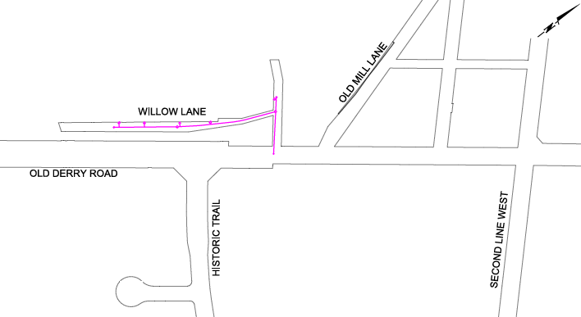

Construction schedule
Construction is planned to begin on or about June 15, 2023 and be completed in autumn 2023. These timelines are estimates, as weather and other unexpected events may impact our timelines. All work is under warranty for two years from the completion date.

Sign up for email notices
Receive timely project updates right to your inbox by signing up for e-notices at peelregion.ca/construction

Contractor and working hours
The work will be completed by the contractor, Technicore Underground Inc., and supported by the engineering consultant Jacobs, both under contract to Peel Region. The contractor’s normal working hours are from 7 a.m. to 7 p.m., Monday to Friday. These hours are consistent with the local municipality’s bylaws. We understand this may cause some inconvenience, but shorter working days would require your neighbourhood to be under construction for a longer period of time.

Connecting to Peel Region’s wastewater system
This construction work provides you with the option to connect your property to Peel Region’s sanitary sewer system. If you decide to connect to Peel’s sanitary sewer system, your wastewater (also known as sewage) would be carried away and treated at our wastewater treatment facilities.
If you choose to receive sanitary sewer service from Peel Region, it will be necessary to install a grinder pumping system and a wastewater service pipe that will carry wastewater from your home to the Regional sanitary sewer system. Installing this grinder pumping system and the pipe would require digging up either the lawn and/or driveway. Please note that Peel Region can only install pipes within the municipal right-of-way up to your property line. It is the homeowner’s responsibility to find a licensed plumber to install the grinder pumping system and the wastewater service pipe on private property at their own cost.
Learn more about how to connect and the applicable fees by emailing the Peel Region Servicing Connections Department at siteplanservicing@peelregion.ca or calling 905-791-7800, extension 7973.

Traffic and parking
To install the new sanitary sewer underground, it will be necessary to close Willow Lane to all traffic for the duration of construction. Pedestrian access will be maintained at all times. To provide an alternate parking location, Willow Lane residents will have the option of parking their vehicles in a secured parking lot located within the Historic Trail Park. Please contact us if you have special needs related to access. In case of an emergency, every effort will be made to provide immediate access to the emergency vehicles.

Interrupting your water supply
We do not expect this construction project to require temporarily shutting off your water.
If we must shut off your water due to an emergency, we will knock on your door to alert you, and do everything we can to fix the problem as quickly as possible.

Areas impacted by construction
Installing sanitary sewers usually requires digging a trench within the municipal right-of-way, which includes the street and the land owned by the municipality between the water service box and the street. (The water service box is a small, round, metal valve located outside, on the property line between your home and the road.) Depending on the location of the sanitary sewer, this trench might cause temporary damage to the road, boulevards, driveway aprons, and lawns within the municipal right-of-way.

Any damage caused by Peel Region’s construction will be repaired. We recommend that you delay any driveway paving or major landscaping projects until this construction work is completed.
In-ground sprinkler systems
As the front lawn may be affected by this construction work, if you have an in-ground sprinkler system we strongly recommend moving any sprinkler lines that are located in the municipal right-of-way. If you can’t relocate these sprinkler lines, please send us a map created by your irrigation contractor or flag each sprinkler head that is located within one meter of the roadway. This will allow us to minimize the impact to your sprinkler system.

Tree protection and trimming
Trees located in the municipal right-of-way will be protected during construction using temporary fencing. If tree branches within the municipal right-of-way interfere with construction, the trees will be pruned beforehand.
If tree branches on private property interfere with construction, they will be pruned back to the nearest suitable trunk or branch. The contractor will contact you before any pruning of private trees occurs. If you do not allow personnel onto your property to trim the tree, the branches will be cut vertically at the property line.

Repairing areas impacted by construction
We will start repairing the road, driveways and lawns impacted by construction once the new sanitary sewer is buried and work has been completed on all wastewater service pipes on your street. Repairs may be delayed due to contractor availability or certain seasonal weather conditions.
For example:
- Paving cannot take place when the ground is saturated with water, or the temperature is below 3°C.
- Asphalt is not available in large volumes during the winter. Asphalt usually becomes available around mid-May.
- Most sod farms are located north of Peel. They usually have sod available beginning in late May. We will replace the sod on your property (if disturbed) once it is available. We replace sod only until the middle of November, weather permitting, to let the sod grow roots. If we do not repair your lawn by the middle of November, we’ll replace the sod the following spring.

Repairing grassy areas
The contractor will replace any damaged sod (grass) on the boulevard or your front lawn and will take care of the new sod for 30 days. You can help the sod stay healthy by watering it. A longer ‘deep root watering’ works better to establish new sod than watering more frequently for a shorter time. Watering in the early morning allows more water to soak in instead of evaporating.

Repairing driveways
- Asphalt driveways: If we need to cut a section of your driveway, the driveway will be repaired by paving a stripe over the disturbed area, resulting in minimal seams in the final driveway. The Region of Peel cannot replace your entire driveway. If you would like to have the rest of your driveway paved, please contact the contractor, Technicore Underground Inc., at (416) 770-0457. The contractor will then share contact information for the company hired to do the paving repairs. Please remember this is your option. If you decide to have your entire driveway repaved, this extra paving work is your responsibility and outside the jurisdiction of the Peel Region.
- Interlock or concrete driveways: If we damaged a portion of your driveway, our contractor will reinstate the damaged portion of the driveway.

Waste collection
If you receive waste collection from the Peel Region, your garbage, recycling, and organics will continue to be picked up on your regularly scheduled day. It is the contractor’s responsibility to move your garbage, recycling, and organics bins from the end of your driveway to a location where waste collection vehicles can pick them up. Empty containers will be returned to their corresponding addresses. Please make sure your house number is clearly marked on each bin. This helps us return empty bins to the correct address.

Vibrations
You could feel slight vibrations from the construction work.

Optional protection plans for your exterior water pipes, wastewater pipes, and in-home plumbing
Many homeowners are not aware that they are responsible for maintaining the water and wastewater pipes both inside their home and outdoors up to the property line. If one of these pipes breaks, it can cause unexpected and costly repairs. Peel Region has partnered with Service Line Warranties of Canada (SLWC) to offer homeowners optional, affordable protection from unexpected home repairs. Learn more about the protection plans at plansforpeel.ca.
Safety during construction
Construction zones require extra caution to keep everyone safe – pedestrians, cyclists, drivers, and construction workers. When driving, walking, or biking through the construction area, please be aware of your surroundings, watch for construction crews and other road users, slow down, account for delays, and consider other routes if possible. To learn more about how to stay safe in construction zones, visit peelregion.ca/workzonesafety

Keeping you informed
We will let you know if there are any major changes to the plans.
Information on this project can also be found at peelregion.ca/pw/construction/miss/162291.htm
Follow Peel Public Works on Twitter (twitter.com/peelpublicworks) for project updates.

We value your feedback
After we have finished, we will invite you to provide feedback on the construction project.
You can sign up to receive this survey electronically at peelregion.ca/construction by clicking ‘Sign up for email notices’.

Thank you for your patience as we complete this necessary work. This work will allow us to provide wastewater services to your home. If you have any questions, please contact us.

Wastewater Collection and Conveyance
Engineering Services Division
Public Works, Region of Peel
Email: construction@peelregion.ca
Phone: 905-791-7800 ext. 4409

