NOTICE OF STUDY COMPLETION – CLASS ENVIRONMENTAL ASSESSMENT
SCHEDULE X
Project Name and Location details

Background:
The Central Mississauga area will experience significant growth over the next 20 + years, specifically within the Mississauga City Centre, Hurontario and Dundas Corridors. We expect these areas to grow by over 40 percent by 2041. The current wastewater infrastructure does not have available capacity to service this increased growth. That’s why the Region has completed an Environmental Assessment (EA) to study how to expand the capacity of the Central Mississauga Wastewater System.
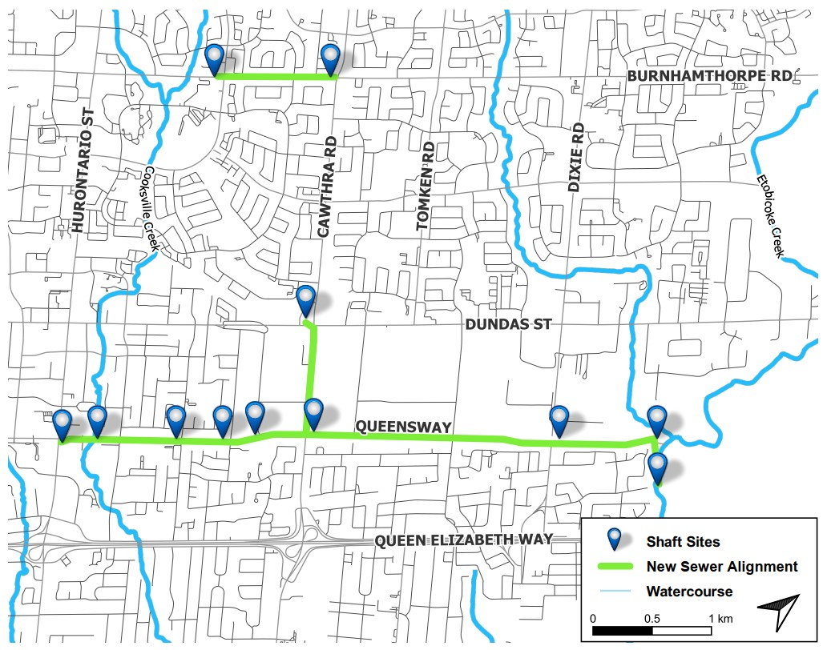
Figure 1: Preferred Solution

Process:
The study followed a Schedule ‘C’ Class EA process, including:
- Public and agency stakeholder meetings
- Looked at ways to improve how wastewater flows through the system
- Investigated alternative long-term servicing strategies, routes, and design concepts
- Confirmed the preferred solution, shown in Figure 1, including alignments, siting, design, and construction timing

Environmental Study Report (ESR):
The ESR will be available for a 30-day public review period starting February 16, 2022 and ending March 18, 2022, in accordance with the requirements of the Municipal Class EA process. An electronic copy of the ESR will be available for public review on the Region of Peel project webpage at:
https://www.peelregion.ca/pw/water/environ-assess/scheduled-c-class-environmental-assessment.asp

Comments and/or Concerns:
If you wish to submit your comments and/or concerns on this project, please contact the Project Manager below. If your concerns cannot be resolved, you may send your Section 16 Order request to the Minister of Environment, Conservation and Parks and the Director of the Environmental Assessment Branch at the following addresses. A copy of the request should also be sent to the Region Project Manager. All requests must be received within the 30-day public review period.

Hon. David Piccini, Minister  Ministry of the Environment, Conservation and Parks  777 Bay Street, 5th Floor,  Toronto, ON  M7A 2J3  Email: Minister.mecp@ontario.ca | Director, Environmental Assessment Branch  Ministry of the Environment, Conservation and Parks  135 St. Clair Avenue West, 1st Floor,  Toronto, ON  M4V 1P5  Email: EABDirector@ontario.ca

The Region of Peel is committed to ensure that all Regional services, programs, and facilities are inclusive and accessible for persons with disabilities. Please contact the Project Manager if you need any accommodations to provide comments or feedback for this study.

Project Manager contact details.

This notice was first issued on [insert date]

