
Peel Water Story Teacher Handbook
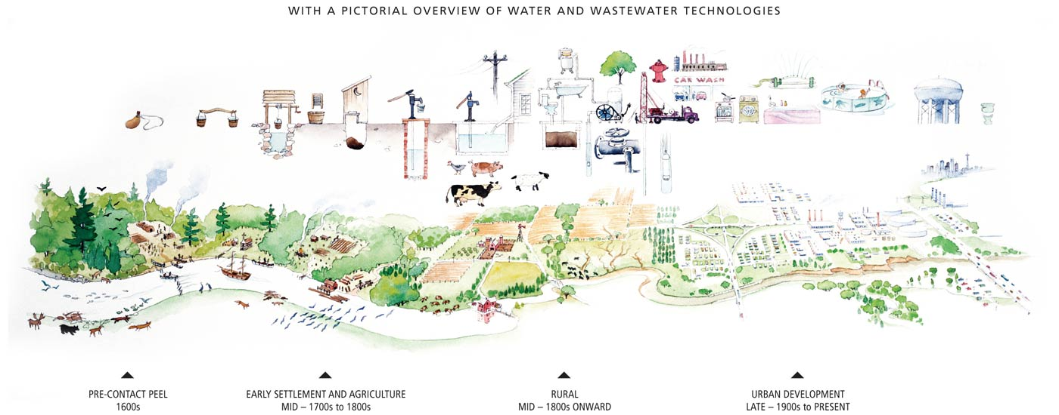
What we do on land is mirrored in the water

Contents
Introduction 4
Why GIS? 4
Lay of the land 6
Module overview 6
Handout answer sheets 7
GIS activity: Your watershed address answer sheet 7
GIS activity: Go with the flow answer sheet 9
In the news: Severe weather event answer sheet 12
Handout activity sheets 13
GIS activity: Your watershed address 13
GIS activity: Go with the flow 15
Curriculum connections 17
Taking the plunge 18
Module overview 18
Handout answer sheets 19
GIS activity: Graphing chloride in the Credit answer sheet 19
Diesel spill article answer sheet 22
In the news: Spill turns creek red answer sheet 23
Handout activity sheets 24
Graphing chloride in the Credit 24
Curriculum connections 28
Rain to drain 30
Module overview 30
Handout answer sheets 31
GIS activity: Growth and water supply answer sheet 31
GIS activity: From source to sink answer sheet 33
GIS activity: What lies beneath answer sheet 35
GIS activity: Human water cycle answer sheet 37
Water comes to Peel – Mississauga and Brampton 38
Lake water comes to Bolton 38
In the news: Watermain break answer sheet 40
Handout activity sheets 41
GIS activity: Growth and water supply 41
GIS activity: From source to sink 43
GIS activity: What lies beneath 45
GIS activity: Human water cycle 47
Curriculum connections 48

Introduction
The Peel Water Story is a series of online learning modules for educators and students in grades 5-12 to learn about local watersheds, water sources, and water quality. The modules use the ArcGIS Online Story Map application, include an introductory element of Geographic Information Systems (GIS), and can be adapted for multiple subject areas. Each module is curriculum-linked and designed to be completed in 40 minutes or less. The modules can be used to deliver an individual lesson or kick-start further exploration and learning.
The Peel Water Story contains 3 modules that were tested and improved upon through feedback from Peel Region District School Board and Dufferin-Peel Catholic District School Board teachers. The modules can be completed in any order.

Module | After completing this module, students will be able to:
Lay of the Land | - Define a watershed  - Use an online map to identify which watershed they live in as well as nearby waterbodies  - Define stormwater and runoff  - Be able to explain the various parts of a stormwater system and why a stormwater system is required
Taking the Plunge | - Define point and non-point source pollution  - Understand how pollutants such as salt enter and impact our watersheds  - Identify the steps taken following a spill
Rain to Drain | - Define surface water and groundwater  - Identify the source and route of their tap water  - Identify the destination and route of their wastewater  - View changes in land use over time

Why GIS?
- Provides real data for students to explore and connect with their community
- Connects students to infrastructure elements that would otherwise be hidden underground or not accessible to the public
- Helps students understand content in many disciplines including geography, history, math, environmental studies, biology, chemistry and enables teachers to find multiple entry points into their curriculum
- Helps visualize data and provide real world applications

Lay of the land

Module overview
Length of lesson: 40 minutes
Preparation: Access to computer lab or class set of laptops / tablets
Key themes: Review of water cycle, watersheds, stormwater, urbanization, and watershed health
Learning goals:
At the end of this module, students will be able to:
- Define a watershed
- Use an online map to identify which watershed they live in and what waterbodies are located within their watershed
- Define stormwater and runoff
- Explain the various components of a stormwater system and their importance
Additional opportunities for discussion:
What are the important natural and historical features in your watershed? How are you connected to the existing ecosystems?
Think about human interventions and how they can impact the watershed. Discuss which have harmed the natural ecosystems and what human interventions are trying to tackle these issues.
How do household and industry activities in your community impact the health of your watershed?

Handout answer sheets

GIS activity: Your watershed address answer sheet
NOTE: Answers to this handout will vary based on the school selected. This answer sheet uses Thomas Street Middle School as an example.
Familiarize yourself with the map. Identify the various FEATURES you will need on the map, including the search bar, layers icon, and zoom functions.
- Your watershed address
Use the following steps to identify the watershed you live in:
- Select the layers icon (beside the search bar) at the top of the map to turn on the school layer. 
- Type your school address in the search bar. Make sure the suggested address that appears is in the correct city and country before selecting it. 
- Zoom out until the name of your watershed appears. What watershed is your school located in?
i.e. Thomas Street Middle School-2640 Thomas St, Mississauga, Ontario, L5M 5G8, Watershed-Credit River

- Nearby water
Use the following steps to follow the water flowing through your watershed:
- Select the layers icon to turn on the rivers, creeks, and streams layers.
- Begin at your school and zoom in or out until you identify the nearest river, creek, or stream. What is the name of the nearest river, creek, or stream?
The closest creek is Mullet Creek.
- Follow this body of water. Does it connect to another river, creek, or stream?
Yes, it connects to the Credit River.
- If yes, what is the name of this second river, creek, or stream?
Lake Ontario

- After watching the videos and using the maps, reflect on water on your school ground. Think about areas where water travels, creates puddles, is absorbed, or goes down a drain. Describe how rainwater might move through your school ground.
Water around my school grounds would pool and flow into catch basins which lead into nearby creeks and rivers. Not much of it would be absorbed on the school grounds because there is mostly pavement and few greenspaces.
- How do you think this movement or storage of water on your school ground can impact the larger watershed?
Since water would runoff the school’s grounds into nearby waterways and not be absorbed greenspaces, it would cause an increase in water levels in the larger watershed.

GIS activity: Go with the flow answer sheet
Familiarize yourself with the watershed map. Identify the various FEATURES you will need on the map, including the search bar, layers icon and zoom functions.
Follow these steps to compare storm water catch basins on school grounds.
- Select the search icon and enter 296 Conestoga Dr, Brampton, Ontario. This address will take you to Heart Lake Secondary School.
  - Select the layers icon (beside the search bar) at the top of the map.
  - Turn off the regional stormwater outflow and regional stormwater main layers.
  - Turn off the City of Brampton catch basin layer.
  - Zoom in until you can see the school property and surrounding streets.
  - How many catch basins are located on the Heart Lake Secondary School property?
Between 13-15
  - Describe the surfaces that immediately surround the school. Are the surfaces permeable or non-permeable?
The surfaces are non-permeable
- Using the same steps, count the number of catch basins at 1305 Cawthra Road, Mississauga, Ontario (Cawthra Park Secondary School – aquatics building)
  - Select the layers icon (beside the search bar) at the top of the map.
  - Turn off the regional stormwater outflow and regional stormwater main layers.
  - Turn off the City of Mississauga catch basin layer.
  - Zoom in until you can see the school property and surrounding streets.
  - How many catch basins are located on Cawthra Park Secondary School property?
There are 0
  - Describe the surfaces that immediately surround the school. Are the surfaces permeable or non-permeable?
The surface that surrounds Heart Lake Secondary School has a school nearby and includes many greenspaces including parks and Etobicoke Creek. Similarly, the surface area that surrounds Cawthra Park Secondary School property has another school beside it and a lot of greenspaces nearby.
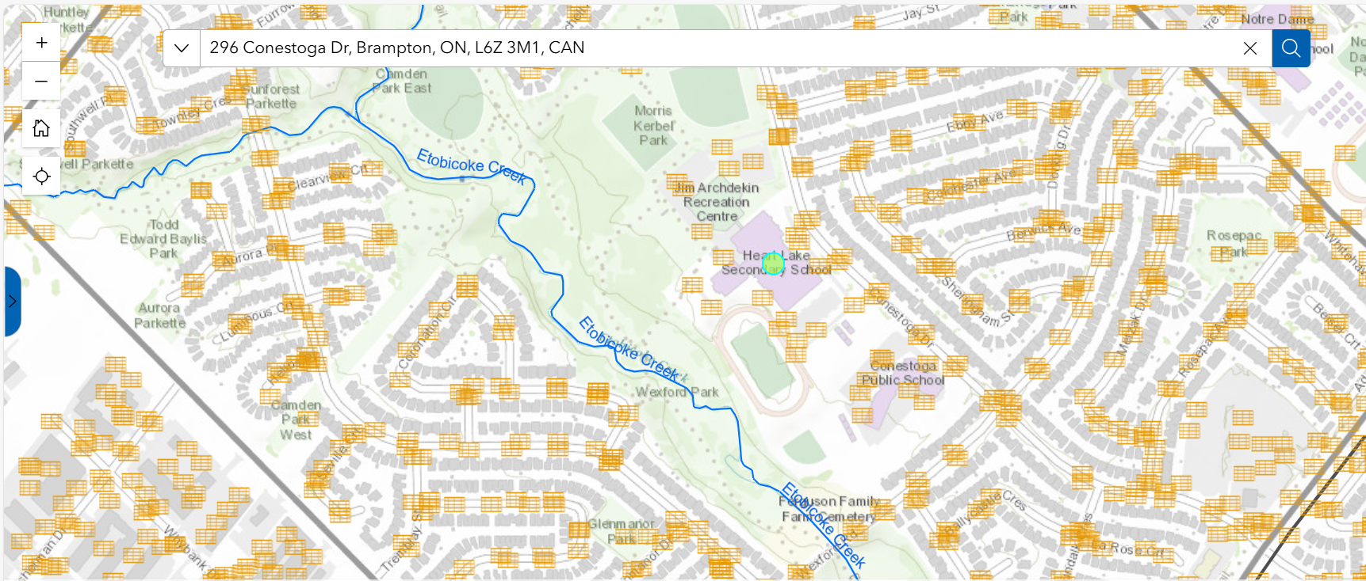
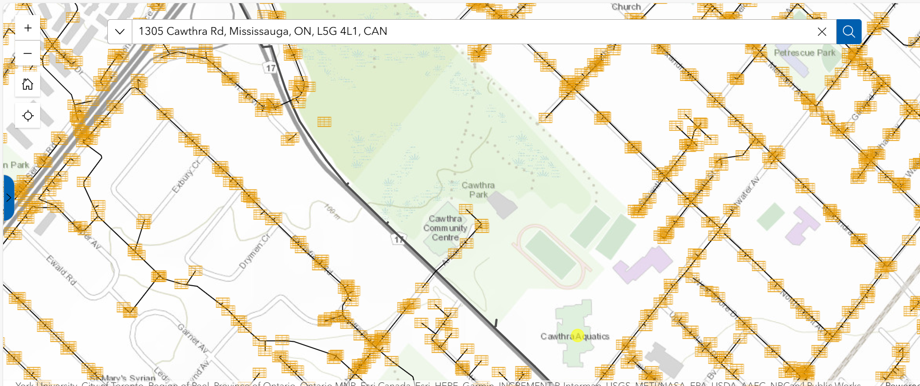
- Based on your understanding of storm water and runoff, what area around each school would contribute to more runoff? What area would reduce runoff?
Roads and developed land are non-permeable surfaces. This means that melted snow and rain would not be able to soak into these surfaces and would pool in low-lying areas. These low-lying areas have more storm drains to direct runoff away from homes, schools, and businesses.

Both schools contribute similar runoff; however, Heart Lake Secondary School has between 13-15 storm drains while Cawthra Park Secondary School has 0. This indicates that runoff is directed toward Heart Lake Secondary School and away from Cawthra Park Secondary School and toward green spaces. Areas with more grass, plants and greenspaces will soak up much more rainwater and snow melt.
- If your school is in Brampton or Mississauga, search for it and look at the school grounds. How does your school compare to the other schools? (Note: at this time, storm water data is only available for the City of Brampton and the City of Mississauga).
Answers will vary depending on the school chosen.

In the news: Severe weather event answer sheet
- Read the severe weather event, news profile and answer the questions below.
  - During a big emergency, like the severe rainstorms in summer 2024, what kinds of teams and specialists need to work together to help keep people safe?

Water and wastewater operations teams, emergency teams, public health, human services, transportation crews, waste teams, and paramedics.

  - What are some things homeowners can do to help reduce the risk of flooding during a major rainstorm?

Homeowners can:
    - Slope soil and driveways away from your home. This directs water away from your home’s foundation.
    - Repair any cracks or holes in the basement walls or floors.
    - Properly seal basement windows and doors.
    - Disconnect downspouts from the ground to direct water onto your lawn and away from your home.
    - Clear drains, gutters, and downspouts of dead leaves and other debris.
- Be prepared and make an emergency kit.
- Report blocked, clogged or damaged catch basins to your local municipality.

  - How is climate change causing storms to become stronger and more intense than they were in the past?

Climate change is making the intensity of extreme weather and storms more common. Warmer temperatures provide more energy to storms, making them more powerful and less predictable. It results in more frequent and severe storms with hazards such as hail, strong winds and flash floods.

Handout activity sheets

GIS activity: Your watershed address
Name:
Familiarize yourself with the map. Identify the various FEATURES you will need on the map, including the search bar, layers icon and zoom functions.
- Your watershed address
Use the following steps to identify the watershed you live in:
- Select the layers icon (beside the search bar) at the top of the map to turn on the school layer.
- Type your school address in the search bar. Make sure the suggested address that appears is in the correct city and country before selecting it.
- Zoom out until the name of your watershed appears. What watershed is your school located in?

- Nearby water
Use the following steps to follow the water flowing through your watershed:
- Select the layers icon to turn on the rivers, creeks, and streams layers.
- Begin at your school and zoom in or out until you identify the nearest river, creek, or stream. What is the name of the nearest river, creek, or stream?

- Follow this body of water. Does it connect to another river, creek, or stream?

- If yes, what is the name of this second river, creek, or stream?

- After watching the videos and using the maps, reflect on water on your school ground. Think about areas where water travels, creates puddles, is absorbed, or goes down a drain. Describe how rainwater might move through your school ground.

- How do you think this movement or storage of water on your school ground can impact the larger watershed?

GIS activity: Go with the flow
Name:
Familiarize yourself with this map. Identify the various FEATURES you will need on the map, including the search bar, layers icon and zoom functions.
Follow these steps to compare storm water catch basins on school grounds.
Note: Storm water data is available for the City of Brampton and City of Mississauga ONLY.
- Select the search icon and enter 296 Conestoga Dr, Brampton, Ontario. This address will take you to Heart Lake Secondary School.
  - Select the layers icon (beside the search bar) at the top of the map.
  - Turn off the regional stormwater outflow and regional stormwater main layers.
  - Turn off the City of Brampton catch basin layer.
  - Zoom in until you can see the school property and surrounding streets.
  - How many catch basins are located on the Heart Lake Secondary School property?

  - Describe the surfaces that immediately surround the school. Are the surfaces permeable or non-permeable?

- Using the same steps, count the number of catch basins at 1305 Cawthra Road, Mississauga, Ontario (Cawthra Park Secondary School – aquatics building)
  - Select the layers icon (beside the search bar) at the top of the map.
  - Turn off the regional stormwater outflow and regional stormwater main layers.
  - Turn off the City of Mississauga catch basin layer.
  - Zoom in until you can see the school property and surrounding streets.
  - How many catch basins are located on Cawthra Park Secondary School property?
  - Describe the surfaces that immediately surround the school. Are the surfaces permeable or non-permeable?

- Based on your understanding of storm water and runoff, what area around each school would contribute to more runoff? What area would reduce runoff?

- If your school is in Brampton or Mississauga, search for it and look at the school grounds. How does your school compare to the other schools? (Note: at this time, storm water data is only available for the City of Brampton and the City of Mississauga).

Curriculum connections
Grade | Subject & Unit | Specific Expectations
6 | Science and Technology: Understanding life systems | - Assess human impacts on biodiversity, and identify ways of preserving biodiversity
7 | Science and Technology: Understanding life systems | - Assess the impacts of human activities and technologies on the environment, and evaluate ways of controlling these impacts
7 | Science and Technology: Understanding matter and energy | - Evaluate the social and environmental impacts of the use and disposal of pure substances and mixtures
8 | Science and Technology: Understanding earth and space systems | - Assess the impact of human activities and technologies on the sustainability of water resources  - Investigate factors that affect local water quality  - Demonstrate an understanding of the characteristics of the Earth’s water systems and the influence of water systems on a specific region
9 | Science | - Assess the impact of human activities on the sustainability of terrestrial and/or aquatic ecosystems, and evaluate the effectiveness of courses of action intended to remedy or mitigate negative impacts  - Investigate factors related to human activity that affect terrestrial and aquatic ecosystems, and explain how they affect the sustainability of these ecosystems
9 | Geography: The Physical Environment and Human Activities | - Analyse various interactions between physical processes, phenomena, and events and human activities in Canada
9 | Geography: The Characteristics of Canada’s Natural Environment | - Describe various characteristics of the natural environment and the spatial distribution of physical features in Canada, and explain the role of physical processes, phenomena, and events in shaping them
10 | Science | - Investigate various natural and human factors that influence Earth’s climate and climate change
11 | Geography: Patterns of Natural and Human Systems | - Describe patterns in natural features and population distribution in the selected region, and analyse the relationship between them
11 | Environmental Science | - Investigate air, soil, and water quality in natural and disturbed environments, using appropriate technology

Taking the plunge

Module overview
Length of lesson: 40 minutes
Preparation: Access to computer lab or set of laptops/tablets
Key themes: Categories of water pollution (point source and non-point source), salt and chloride levels in our watersheds and spill cleanup protocols
Learning goals:
At the end of this module students will be able to:
- Define point source and non-point source pollution
- Understand the negative impacts of salt our watersheds
- Use an online map to identify areas in their watersheds with high levels of chloride
- Understand how spills are treated and cleaned up in our waterways
Additional discussion opportunities:
What are some other examples of point source and non-point source pollution in our Region?
Can you think of a time where pollution (point source or non-point source) has affected your daily life?
Think about why salt might affect species of native plants and animals in our watershed, even though it is a natural substance and is found in many different waterways across the world. Discuss which types of animals or species would be more affected by high salt concentrations than others.
What are some ways we could prevent or decrease the number of point source spills occurring in our Region? What about our country?

Handout answer sheets

GIS activity: Graphing chloride in the Credit answer sheet
Familiarize yourself with the map. Identify the various FEATURES you will need on the map, including the search bar, layers icon and zoom functions.
- Use the following steps to view the chloride monthly average data:
  - Zoom out until you can see all of Peel Region on your screen.
  - Select the layers icon (beside the search bar) and make sure that the Chloride Monthly Average layer is turned on.
  - Select the purple dots that represent the locations listed on the table in your handout.
  - Use the data to complete the table on your handout.
- Use the following steps to identify land use type:
  - Select the layers icon at the top of the map, to turn on the Land Use layer.
  - Click on legend to show the land use types.
  - Identify the land use type immediately surrounding each location (this may include more than one type of land use) and enter this information in the table on your handout.
Location | January Monthly Average  Chloride (mg/L) | April Monthly Average  Chloride (mg/L) | August Monthly Average  Chloride (mg/L) | November Monthly Average Chloride (mg/L) | Land Use Type
Credit River at Highway 10 | 550 | 231 | 272 | 431 | Rural
Credit River at Belfountain Conservation Area | 51 | 41 | 48 | 88 | Conservation Area
Fletchers Creek | 1,470 | 541 | 264 | 368 | Estate
Cooksville Creek at Lakeshore | 3,318 | 1,188 | 493 | 2,181 | Employment
- Using the graph paper on your handout and data from your table, plot the chloride levels throughout the year for each location.
  - Use a pencil crayon and ruler to connect the dots representing chloride levels at each location.
  - Use different colours for different locations (example: use red to connect the dots you plotted for the Credit River at Highway 10 location and a green to connect the dots you plotted for the Fletchers Creek location).
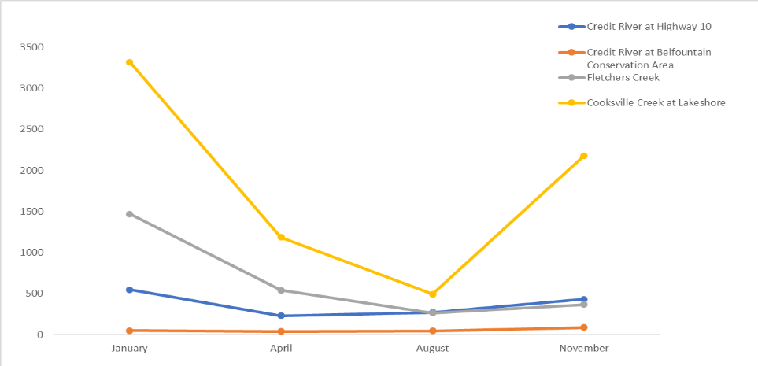

- Now use the table and graph you’ve created to answer the questions below about the 2019 Credit River chloride levels.
  - At which location were chloride levels the highest? In which month did this occur?
Chloride levels are the highest at Cooksville Creek at Lakeshore. This occurred in January.
  - Why do you think chloride levels were the highest in this month?
The chloride levels are the highest in this month because it is winter and more road salt is being used on icy roads and sidewalks.
  - What kind of land use is associated with the highest chloride levels?
The land use type that is associated with the highest chloride levels are employment areas.
  - What kind of land use is associated with the lowest chloride levels?
The land use type associated with the lowest chloride levels are conservation areas.
  - What patterns or changes do you notice about chloride levels in urban areas versus chloride levels in rural areas?
In more rural areas the chloride levels stay relatively constant in all four months, in urban areas the levels increase dramatically during winter months (November and January).
- According to the Canadian Water Quality Guidelines for the Protection of Aquatic Life, the long-term exposure limit for certain freshwater species is 120 mg/L of chloride. This number is used to identify areas where chloride levels are high enough to negatively impact aquatic plants and fish.
  - Using a pencil crayon and ruler, draw a line to show 120 mg/L on your graph.
  - Are any of the locations below the long-term exposure limit?
The only location below the long-term exposure limit is Credit River at Belfountain Conservation Area.
  - Do any of the locations exceed the long-term exposure limit?
The Credit River at Highway 10, Cooksville Creek at Lakeshore and Fletchers Creek are all above the long-term exposure limit of 120 mg/L. This means that all locations (other than Credit River at Belfountain Conservation Area) have chloride levels that are far too high for certain aquatic plant and fish species and can cause negative impacts to the species found in these locations.
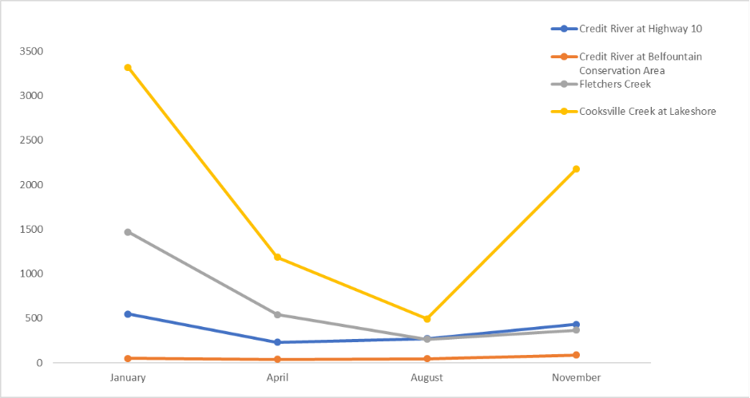
- Use data from the Credit Valley Conservation Authority Real-Time Monitoring site to explore current salt levels in our watersheds.

Diesel spill article answer sheet
- Read the Diesel Spill article and answer the questions below.
  - What was spilled?
Diesel
  - What was the source of the spill?
A ruptured saddle tank from the tow truck caused the diesel to spill into the basin.
  - Is this an example of point source or non-point source pollution?
Point source pollution because the source of the spill was identified to one location.
  - How was the spill treated and cleaned up?
A boom was placed on the spill to contain it and prevent it from travelling downstream. The boom was left overnight to help soak up the diesel.
- Use the internet to research Spill Coordinator careers and describe the academic and professional experience required for this job. Try searching for oil spill coordinator, environmental response coordinator, and environmental technician to expand the search.
For this position a Bachelor of Science degree is typically required in Mechanical, Environmental or Maritime disciplines. Excellent leadership and problem-solving skills are required as they must be able to direct instructions clearly and problem solve on demand as spills can change rapidly. Other requirements include First Aid training, heavy equipment operations and experience in working with chemical compounds.

In the news: Spill turns creek red answer sheet
- Read the spill turns creed red, news profile and answer the questions below.
  - During a spill what kinds of teams or organizations need to work together to contain and remove spilled material?
Peel Region, Ministry of the Environment Conservation and Parks (MECP), the company responsible for the spilled material, contractor (if hired by the company responsible), local regulatory and compliance groups (Toronto Water Environmental Monitoring & Protection), and the Ministry of Environment and Climate Control (MOECC)
  - What are some things you can do at home to prevent household paints, oils, and chemicals from entering the environment?
- Do not pour them down the drain, or down the storm sewer.
- Do not throw them in the garbage
- Store properly to prevent leaks and spills
- Take unused paints and chemicals to your local Community Recycling Centre.
  - How do neighbourhoods (residential, commercial, and institutional) impact the water quality in local rivers and streams?
Residential
Pesticides, fertilizers, car fluids, paints, and cleaning products commonly end up in the storm drain. These chemicals can harm plants and animals by disrupting food chains, polluting habitats, and lowering water quality. Even small amounts can have long-term impacts on aquatic life.
Commercial
Fuel, oil, chemical, and waste from businesses that are manufactured and transported can end up in local rivers and streams. These products are either accidentally or intentionally released into the environment and can have significant impacts on the environment affecting plants, animals, habitats, water quality, and aquatic life.
Institutional
Fluids (chemicals, oils, detergents, degreasers, fuels) may be accidentally or improperly disposed of by businesses (buildings), schools, government offices, warehouses, airports, and hospitals down the drain or storm sewer. This can cause damage to pipes and infrastructure in the municipal wastewater and stormwater systems.

Handout activity sheets

Graphing chloride in the Credit
Name:
Familiarize yourself with the map. Identify the various FEATURES you will need on the map, including the search bar, layers icon and zoom functions.
- Use the following steps to view the chloride monthly average data:
  - Zoom out until you can see all of Peel Region on your screen.
  - Select the layers icon (beside the search bar and make sure that the Chloride Monthly Average layer is turned on.
  - Select the purple dots that represent the locations listed on the table in your handout.
  - Use the data to complete the table on your handout.
- Use the following steps to identify land use type:
  - Select the layers icon at the top of the map, to turn on the Land Use layer.
  - Click on legend to show the land use types.
  - Identify the land use type immediately surrounding each location and enter this information in the table on your handout (Sliver Creek at Willow Park not included).
Location | January Monthly Average  Chloride (mg/L) | April Monthly Average  Chloride (mg/L) | August Monthly Average  Chloride (mg/L) | November Monthly Average Chloride (mg/L) | Land Use Type
Credit River at Highway 10

Credit River at Belfountain Conservation Area
Fletchers Creek

Cooksville Creek at Lakeshore
- Using the graph paper on your handout and data from your table, plot the chloride levels throughout the year for each location.

  - Use a pencil crayon and ruler to connect the dots representing chloride levels at each location.
  - Use different colours for different locations (example: use red to connect the dots you plotted for the Credit River at Highway 10 location and a green to connect the dots you plotted for the Fletchers Creek location).
- Now use the table and graph you’ve created to answer the questions below about the 2019 Credit River chloride levels.
  - At which location were chloride levels the highest? In which month did this occur?

  - Why do you think chloride levels were the highest in this month?

  - What kind of land use is associated with the highest chloride levels?

  - What kind of land use is associated with the lowest chloride levels?

  - What patterns or changes do you notice about chloride levels in urban areas versus chloride levels in rural areas?

- According to the Canadian Water Quality Guidelines for the Protection of Aquatic Life, the long-term exposure limit for certain freshwater species is 120 mg/L of chloride. This number is used to identify areas where chloride levels are high enough to negatively impact aquatic plants and fish.
  - Using a pencil crayon and ruler, draw a line to show 120 mg/L on your graph.
  - Are any of the locations below the long-term exposure limit?

  - Do any of the locations exceed the long-term exposure limit?

- Use data from the Credit Valley Conservation Authority Real-Time Monitoring site to explore current salt levels in our watersheds. How does it compare to 2019 levels?
  - Select Water Quality Table from right navigation (Station Data at-a-Glance).
  - Select Chloride from navigation bar above the station column in the table.
  - Locate station name and record the latest chloride level.

Curriculum connections
Grade | Subject & Unit | Specific Expectations
5 | Science and Technology: Understanding matter and energy | - evaluate the social and environmental impacts of processes used to make everyday products
6 | Science and Technology: Understanding life systems | - assess human impacts on biodiversity, and identify ways of preserving biodiversity
7 | Science and Technology: Understanding life systems | - assess the impacts of human activities and technologies on the environment, and evaluate ways of controlling these impacts
7 | Science and Technology: Understanding matter and energy | - evaluate the social and environmental impacts of the use and disposal of pure substances and mixtures
8 | Science and Technology: Understanding earth and space systems | - assess the impact of human activities and technologies on the sustainability of water resources  - investigate factors that affect local water quality
9 | Science | - assess the impact of human activities on the sustainability of terrestrial and/or aquatic ecosystems, and evaluate the effectiveness of courses of action intended to remedy or mitigate negative impacts  - investigate factors related to human activity that affect terrestrial and aquatic ecosystems, and explain how they affect the sustainability of these ecosystems
9 | Geography: The Physical Environment and Human Activities | - analyse various interactions between physical processes, phenomena, and events and human activities in Canada
10 | Science | - investigate various natural and human factors that influence Earth’s climate and climate change
11 | Biology | - analyse the effects of various human activities on the diversity of living things
11 | Chemistry | - analyse the properties of commonly used chemical substances and their effects on human health and the environment, and propose ways to lessen their impact  - analyse the origins and effects of water pollution, and a variety of economic, social, and environmental issues related to drinking water
11 | Environmental Science | - investigate air, soil, and water quality in natural and disturbed environments, using appropriate technology  - analyse the effects on human health of environmental contaminants and a significant environmental phenomenon
12 | Chemistry | - demonstrate an understanding of chemical reactions that occur in the environment as a result of both natural processes and human activities

To learn more about other Peel Region education programs and resources visit: http://www.peelregion.ca/enviroed

Rain to drain

Module overview
Length of lesson: 40 minutes
Preparation: Access to computer lab or set of laptops/tablets
Key themes: Water sources, groundwater, surface water, and water supply
Learning goals:
At the end of this module students will be able to:
- Define surface water and groundwater
- Use an online map to identify the source and route of their tap water
- Use an online map to identify the destination and route of their wastewater
- Use an online map to view changes in land-use over time and be able to explain how different land use practices can influence water supply
Additional discussion opportunities:
Discuss the use of tap water and bottled water and how they are different. Have students research the sources of bottled water.
Discuss growth and change throughout Peel Region over time and how patterns of land use have changed.
Have students research the history of the Etobicoke Creek, the settlement of downtown Brampton, issues with flooding, and the large construction project to divert the creek. Discuss how the diversion impacted humans, animals, and natural features surrounding the creek.

Handout answer sheets

GIS activity: Growth and water supply answer sheet

Note: Answers to this handout will vary. This answer sheet uses Mayfield Secondary School as an example.
Familiarize yourself with the map. Identify the various FEATURES you will need on the map, including the search bar, time slider bar, layers icon and zoom functions.
Use this map and time slider bar to explore how land use has changed over time in your immediate community and across Peel Region. You can pause the time slider as needed.
- Use the following steps to identify land use in your community:
  - Select the search bar and enter your school address.
  - Begin at your school and zoom out until you have a view of the surrounding neighbourhood.
  - Click on the play symbol below the time slider bar and pause when you reach the end to see the current land use.
  - Select legend in the layers icon and review the different land use categories.
- What is the most common land use in the community and surrounding area?
Rural
- Has the land use category changed in and around your neighbourhood?
There was little change in land use up until 2003 when residential land use expanded dramatically.
  - Click on the time slider bar to see the changes in land use over time.
- What kind of development did you notice?
There was only a small area of residential land with the rest of the land type not labelled until 2003.
- How do you think these developments would have affected the water source?
As the area around Bolton and throughout Peel Region became more developed, we saw more residential, employment and institutional uses of land. These land uses would have increased the amount of pollution, run off, and other factors that impact our water sources today and increased demands for water use.
- Do you think the water still comes from the same source today as it did in 1950?
Areas like Brampton and the community of Bolton previously relied heavily on groundwater for their source of water but as the land became more developed and the population grew, they would have switched to Lake Ontario as their water source.

GIS activity: From source to sink answer sheet

Note: Answers to this handout will vary. This answer sheet Thomas Street Middle School as an example.
Familiarize yourself with this map. Identify the various FEATURES you will need on the map, including the search bar, layers icon and zoom functions.
Use this map to explore the world beneath your feet – Peel’s extensive water distribution network. Remember, Peel’s water treatment systems can be divided into two categories: surface water treatment and groundwater treatment sites.
- Use the following steps to locate the two Water Treatment Plants located near Lake Ontario:
  - Select the search bar and enter your school address.
  - Zoom out so that your school and Lake Ontario are both displayed on the screen.
  - Using the layers icon, make sure that the following layers are turned on:
Water treatment plant – active
Water main diameter greater than 700mm
  - Turn off all the other layers to make it easy to view the relevant information.
  - Find the two Water Treatment Plants located on the shores of Lake Ontario. What are their names?
Arthur P. Kennedy Water Treatment Plant
Lorne Park Water Treatment Plant
- The water main trunks are the largest water mains that carry water from the Water Treatment Plant to smaller water mains leading to homes, schools, and businesses. Use the following steps to locate the name of the Water Treatment Plant closest to our school:
  - Using the layers icon, turn on the water main layer.
  - Trace the water flow from the Water Treatment Plant to your School area.
  - As you zoom in on the map you will notice that the smaller water mains become visible.
  - What is the name of the Water Treatment Plant that is closest to your school?
Lorne Park Water Treatment Plant
  - What size is the water main trunk that leaves the Water Treatment Plant? (the size is provided in millimeters)
2100 mm
- Zoom in to your school property. What is the size of the water main outside your school?
600 mm

GIS activity: What lies beneath answer sheet

Note: Answers to this handout will vary. This answer sheet Thomas Street Middle School as an example.
Familiarize yourself with the map. Identify the various FEATURES you will need on the map, including the search bar, layers icon and zoom functions.
Use this map to explore the world beneath your feet – Peel’s extensive water distribution network. Remember, Peel’s water treatment systems can be divided into two categories: surface water treatment and groundwater treatment sites.
- Use the following steps to trace the route that wastewater takes to get from your school to the Water Resource Recovery Facility (wastewater treatment plant):
  - Select the search bar and enter your school address.
  - Zoom out so that your school and Lake Ontario are both displayed on the screen.
  - Using the layers icon, make sure that the following layers are turned on:
Water Resource Recovery Plant – active
Wastewater Main Diameter Greater than 600mm
  - Turn off all the other layers to make it easy to view the relevant information.
  - Find the two Water Resource Recovery Facilities (wastewater treatment plants) located on the shores of Lake Ontario. What are their names?
Clarkson Wastewater Treatment Plant
G.E. Booth Wastewater Treatment Plant
- The wastewater main trunks are the largest pipes that carry wastewater from schools, homes, and businesses to the Water Resource Recovery Facility. To trace the flow of wastewater from your school to the Water Resource Recovery Facility, use the following steps:
  - Turn on the wastewater main layer.
  - As you zoom in on the map you will notice that the smaller wastewater mains become visible. What is the name of the Water Resource Recovery Facility that is closest to your school?
Clarkson Wastewater Treatment Plant
  - What sizes are the wastewater main trunks that leave the Water Resource Recovery Facility? (the size is provided in millimeters)
3000 mm
- Zoom in to your school property. What is the size of the wastewater main outside your school?
600 mm

GIS activity: Human water cycle answer sheet

Note: Answers to this handout will vary. This answer sheet Thomas Street Middle School as an example.
Familiarize yourself with this map. Identify the various FEATURES you will need on the map, including the search bar, layers icon and zoom functions.
- Use the following to see both the water and wastewater infrastructure in Peel:
  - Using the layers icon, turn on the following layers:
Water Main Diameter Greater than 700
Wastewater Main Diameter Greater than 600
- Why do you think the wastewater trunks follow a curvy route to reach the Water Resource Recovery Facility (wastewater treatment plant) rather than running in straight lines like the water main trunks?
Wastewater trunks follow the natural slope of the land and rely on gravity to reach the wastewater treatment plants while the water main trunks must move slightly uphill to homes and institutions and must be pumped. It makes most sense for the water to be pumped in one straight line rather than curved.
- What layer on the map can you turn on to confirm your theory?
Turn on Rivers, Creeks, and Streams, as they follow the natural slope of the land and match the route of the wastewater trunks.

Water comes to Peel – Mississauga and Brampton
Based on what you read in the article, answer the questions below:
- Which community in Peel was the first to use Lake Ontario as a source of municipal water?
Port Credit
- What year did the Lakeview (Arthur P. Kennedy) Water Treatment Plant open?
1953
- What local Lake was originally the sole source of Bramptons municipal water supply?
Heart Lake
- What year did Brampton start receiving water from Lake Ontario as it's municipal water supply?
1966

Lake water comes to Bolton
- Based on what you read in the article, answer the questions below:
  - What year did Bolton build its first series of water pipes?
1939
  - In 1999, what was the water source for Bolton?
Five wells supplied water to Bolton’s municipal groundwater system.
  - What is currently Bolton’s water source?
Lake Ontario
- Use the internet to research careers in Water and Wastewater as a Water Distribution Operator. Describe the academic and professional experience required for this job. Try searching for oil spill coordinator, environmental response coordinator, and environmental technician to expand the search.
For this position, the minimum requirement, is to obtain the Water Distribution and Wastewater Collection, Operator in Training (OIT) licence. You can then apply to become an entry level operator. Other things include:
Qualifications
- Water and Wastewater Operator-in-Training or Operator Certification.
- Equipment operator licenses.
- Valid AZ driver’s license.
Required skills and abilities
- Operating and maintaining manual and power equipment
- Problem solving
- Working outdoors
- Learning hands-on skills
- Performing heavy lifting and physical labour
There are 4 progressive level. s (class 1-4) after the initial OIT training. You must get 1 year (1,800 hours) of practical operations experience and pass the mandatory level 1 (class 1) exam. You can then apply to become a level 1 operator.
OIT (Operator-in-Training): Entry tier to gain initial experience.
Class 1: 1 year of experience plus exam.
Class 2: 3 cumulative years of experience.
Class 3: 4 years of experience plus advanced education/Continuing Education Unit upgrades
Class 4: 4 years of high-level experience and extensive education.
You can find more info here: Career spotlight: water and wastewater operator - peelregion.ca

In the news: Watermain break answer sheet
- Read the severe weather event, news profile and answer the questions below.
  - Why was the failure of the 750 mm watermain considered a priority for the community?
It was considered a priority because of the large number (36,000) people and businesses that it impacted.

  - What steps were taken to repair the watermain?
The team investigated the issue to confirm that the 750mm watermain was the one that failed, they created a plan to isolate the damaged section, prepared for repairs by draining 625,000 litres of water from the pipe, implemented a temporary water-use ban on some actions (to minimize the amount of water being used), located the source of the leak, removed and replaced the damaged saddle pipe connector, and finally restored the water service once the repair was completed.
  - What water uses were not allowed during the emergency?
All outdoor water use was stopped including:
- Using a hose to water lawns, gardens, flowers, and gardens
- Washing windows, sidewalks, driveways, or vehicles.
- Filling decorative fountains, ponds, pools, or hot tubs.
- Using water for construction purposes like grading and dust control.
- Use of automatic irrigation systems.
- Having outdoor fires.
  - Is there construction going on in your neighbourhood? If there is, what work is being done? https://peelregion.ca/construction/projects/current-construction-projects
Peel Region Ask students to look up an address in their neighbourhood or home to find out the answer to this question.

  - Who is responsible for the water service pipe located from a homeowners property line to the road? Find out by visiting Replacing your private-side water pipe - peelregion.ca
Peel Region

Handout activity sheets

GIS activity: Growth and water supply
Name:
Note: Answers to this handout will vary. This answer sheet uses Mayfield Secondary School as an example.
Familiarize yourself with the map. Identify the various FEATURES you will need on the map, including the search bar, time slider bar, layers icon and zoom functions.
Use this map and time slider bar to explore how land use has changed over time in your immediate community and across Peel Region. You can pause the time slider as needed.
- Use the following steps to identify land use in your community:
  - Select the search bar and enter your school address.
  - Begin at your school and zoom out until you have a view of the surrounding neighbourhood.
  - Click on the play symbol below the time slider bar and pause when you reach the end to see the current land use.
  - Select legend in the layers icon and review the different land use categories.
- What is the most common land use in the community and surrounding area?

- Has the land use category changed in and around your neighbourhood?
  - Click on the time slider bar to see the changes in land use over time.

- What kind of development did you notice?

- How do you think these developments would have affected the water source?

- Do you think the water still comes from the same source today as it did in 1950?

GIS activity: From source to sink
Name:
Note: Answers to this handout will vary. This answer sheet Thomas Street Middle School as an example.
Familiarize yourself with this map. Identify the various FEATURES you will need on the map, including the search bar, layers icon and zoom functions.
Use this map to explore the world beneath your feet – Peel’s extensive water distribution network. Remember, Peel’s water treatment systems can be divided into two categories: surface water treatment and groundwater treatment sites.
- Use the following steps to locate the two Water Treatment Plants located near Lake Ontario:
  - Select the search bar and enter your school address.
  - Zoom out so that your school and Lake Ontario are both displayed on the screen.
  - Using the layers icon, make sure that the following layers are turned on:
Water treatment plant – active
Water main diameter greater than 700mm
  - Turn off all the other layers to make it easy to view the relevant information.
  - Find the two Water Treatment Plants located on the shores of Lake Ontario. What are their names?

- The water main trunks are the largest water mains that carry water from the Water Treatment Plant to smaller water mains leading to homes, schools, and businesses. Use the following steps to locate the name of the Water Treatment Plant closest to our school:
  - Using the layers icon, turn on the water main layer.
  - Trace the water flow from the Water Treatment Plant to your School area.
  - As you zoom in on the map you will notice that the smaller water mains become visible.
  - What is the name of the Water Treatment Plant that is closest to your school?

  - What size is the water main trunk that leaves the Water Treatment Plant? (the size is provided in millimeters)

- Zoom in to your school property. What is the size of the water main outside your school?

GIS activity: What lies beneath
Name:
Note: Answers to this handout will vary. This answer sheet Thomas Street Middle School as an example.
Familiarize yourself with the map. Identify the various FEATURES you will need on the map, including the search bar, layers icon and zoom functions.
Use this map to explore the world beneath your feet – Peel’s extensive water distribution network. Remember, Peel’s water treatment systems can be divided into two categories: surface water treatment and groundwater treatment sites.
- Use the following steps to trace the route that wastewater takes to get from your school to the Water Resource Recovery Facility (wastewater treatment plant):
  - Select the search bar and enter your school address.
  - Zoom out so that your school and Lake Ontario are both displayed on the screen.
  - Using the layers icon, make sure that the following layers are turned on:
Water Resource Recovery Plant – active
Wastewater Main Diameter Greater than 600mm
  - Turn off all the other layers to make it easy to view the relevant information.
  - Find the two Water Resource Recovery Facilities (wastewater treatment plants) located on the shores of Lake Ontario. What are their names?

- The wastewater main trunks are the largest pipes that carry wastewater from schools, homes, and businesses to the Water Resource Recovery Facility. To trace the flow of wastewater from your school to the Water Resource Recovery Facility, use the following steps:
  - Turn on the wastewater main layer.
  - As you zoom in on the map you will notice that the smaller wastewater mains become visible. What is the name of the Water Resource Recovery Facility that is closest to your school?

  - What sizes are the wastewater main trunks that leave the Water Resource Recovery Facility? (the size is provided in millimeters)

- Zoom in to your school property. What is the size of the wastewater main outside your school?

GIS activity: Human water cycle

Note: Answers to this handout will vary. This answer sheet Thomas Street Middle School as an example.
Familiarize yourself with this map. Identify the various FEATURES you will need on the map, including the search bar, layers icon and zoom functions.
- Use the following to see both the water and wastewater infrastructure in Peel:
  - Using the layers icon, turn on the following layers:
Water Main Diameter Greater than 700
Wastewater Main Diameter Greater than 600
- Why do you think the wastewater trunks follow a curvy route to reach the Water Resource Recovery Facility (wastewater treatment plant) rather than running in straight lines like the water main trunks?

- What layer on the map can you turn on to confirm your theory?
.

Curriculum connections
Grade | Subject & Unit | Specific Expectations
5 | Science and Technology: Understanding matter and energy | - evaluate the social and environmental impacts of processes used to make everyday products
8 | Science and Technology: Understanding earth and space systems | - assess the impact of human activities and technologies on the sustainability of water resources  - demonstrate an understanding of the characteristics of the earth’s water systems and influence of water systems on a specific region
9 | Geography: The Physical Environment and Human Activities | - analyse various interactions between physical processes, phenomena, and events and human activities in Canada
9 | Geography: Demographic Patterns and Trends | - analyse patterns of population settlement and various demographic characteristics of the Canadian population
10 | Science | - investigate various natural and human factors that influence Earth’s climate and climate change
11 | Chemistry | - analyse various interactions between physical processes, phenomena, and events and human activities in Canada
11 | Geography: Patterns of Natural and Human Systems | - describe patterns in natural features and population distribution in the selected region, and analyse the relationship between them
12 | Biology | - analyse the relationship between population growth, personal consumption, technological development, and our ecological footprint, and assess the effectiveness of some Canadian initiatives intended to assist expanding population

To learn more about other Peel Region education programs and resources visit: http://www.peelregion.ca/enviroed

